**PREFACE**

**The ‘KNOWLEDGE GUIDE’ is an online Bookstore Management System project to automate all kinds of activity in the bookstore. The project aims in developing a computerized bookstore and to maintain the daily work of a bookstore. This Bookstore Management System has the feature of user login and admin login. Through the admin login the admin can monitor the whole system, and can maintain the bookstore. The admin can add or remove books available in the bookshop.**

**It can also manage the order processing and stock management.**

**Overall this project provides the facility to the customer of the shop to purchase books from the bookstore and it keeps all the records of the books, sales, stock details and authors.**

**Organization of the project: TECHNO INDIA GROUP**



**Acknowledgment**

**I would like to take this opportunity to express our special thanks of gratitude to our project mentor, Prof. Soumyadip Saha for his constant guidance and support in completing this project.**

**I AM also Thankful to all the other faculty members for their fruitful advice and support.**

**I would take this opportunity to thank our parents and everyone who directly and indirectly helped us out with this project.**

**Last but not least we thank Almighty God, without whom nothing would have been possible.**

**itzsoumyadip**

**Online BOOKSTORE management system**

**Table of contents**

**1.project aims and objectives**

**2.software specification**

**3. hardware cpu**

**4.software running environment**

**5.Designs and modules**

**6. coding standards and assumptions**

**7. testing**

**8.future scope**

**9. conclusion**

**11.bibliography**



**1, Project aims and objectives**

**The aims and objectives that will be achieved after the completion of this project are as follows:**

* **Online buying of books.**
* **User signup.**
* **Login page for existing users.**
* **Admin login page where the admin can add or remove books in the list of available books.**
* **A search column for the user to search for the desired book.**
* **Cart to display the books the user desires to buy.**
* **Contact details for contacting in case of emergency.**
* **‘My orders’ option for the user to check out his orders and expected delivery dates.**

**2. Software specification**

**2.1 Xampp: The Xampp web server is used for the testing and running the project.**

**2.2 Operating System: Windows 7 is used as the operating system as it is stable and user friendly.**

**2.3 Sublime Text: Sublime text is a clean, functional and fast code editor which supports plugins, snippets and many other things.**

**3. Hardware specification**

**3.1 1 GB RAM:RAM 1 GB is used which will provide faster reading and writing capabilities will in turn support faster processing.**

**3.2 Hard Disk Drive 40 GB: HDD 40 GB is used for storing and retrieving of large amount of data.**

**4. software running environment**

**4.1 Operating system:**

* **Windows 7 onwards**
* **Linux (workstation)**

**4.2. Browser specification:**

* **Internet Explorer 8 onwards**
* **Google Chrome**
* **Firefox**

**\*All the browsers need to be compatible with HTML 5.**



**5. Designs and modules**

* **ENTITY RELATIONSHIP DIAGRAM**

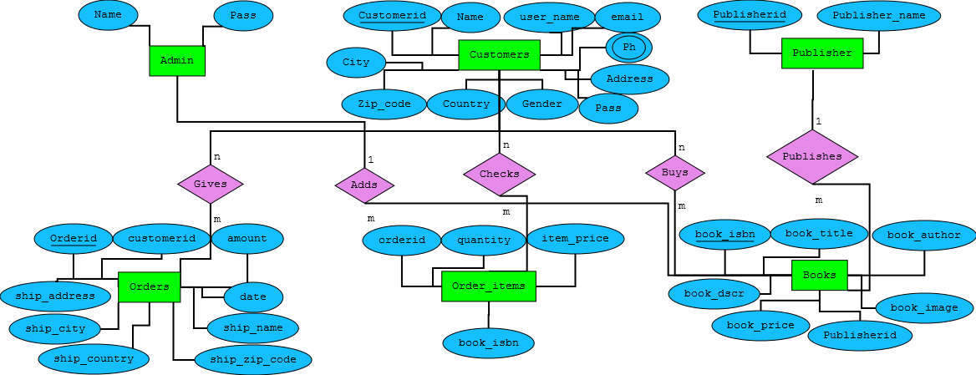

* **USER CASE DIAGRAM**

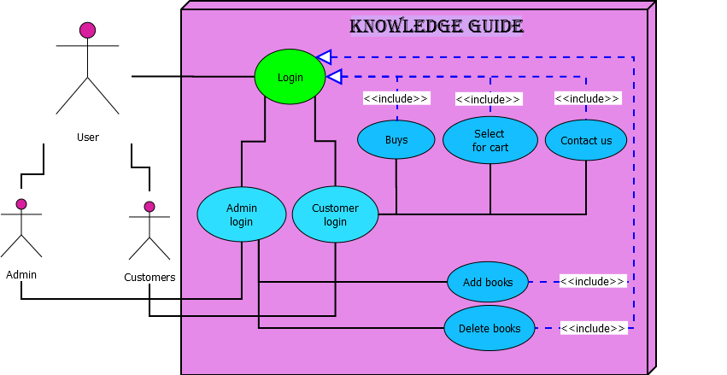

* **DATA FLOW DIAGRAM**

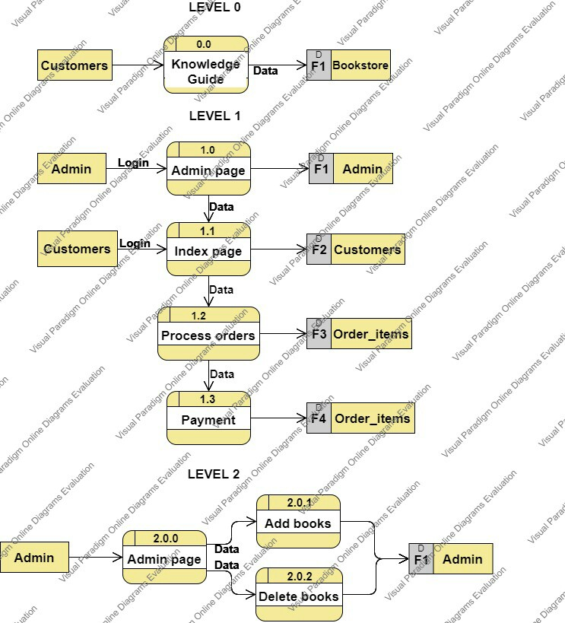

* **COCOMO**

**Basic model equation:**

1. **Effort=a(KLOC) b**
2. **Tdev.= c(effort) d**

|  |  |  |  |  |
| --- | --- | --- | --- | --- |
| **Mode** | **A** | **B** | **C** | **d** |
| **Organic** | **2.4** | **1.05** | **2.5** | **0.38** |
| **Semi-detached** | **3.0** | **1.12** | **2.5** | **0.35** |
| **Embedded** | **3.6** | **1.20** | **2.5** | **0.32** |

**Considering it to be of Organic Type:**

**KLOC=1.1**

**Effort=2.4(1.1)1.05 =2.65**

**Tdev= 2.5(2.65)0.38 =3.62 months**

**=4months (approx)**

* **Snapshots**

**Sign Up Page**

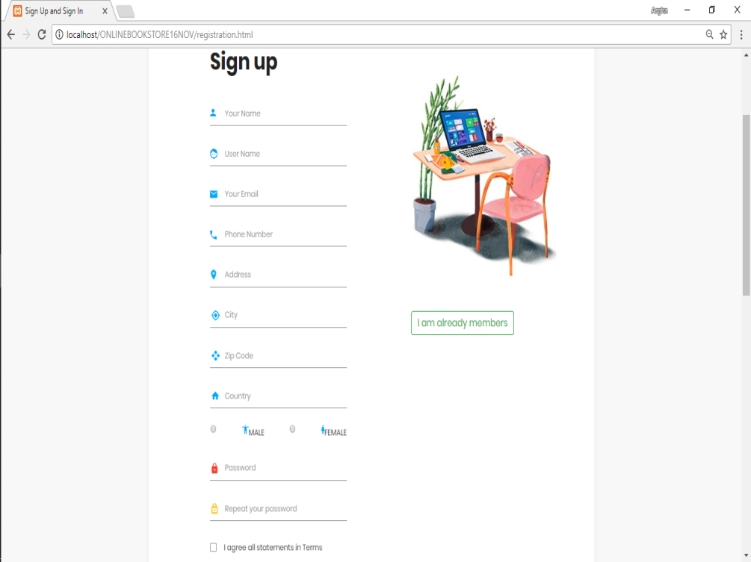

**Sign In page**

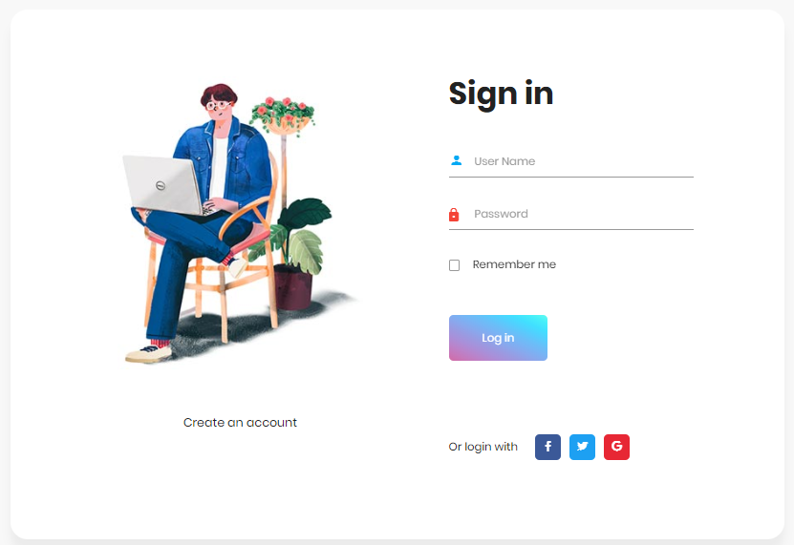

**Home page**

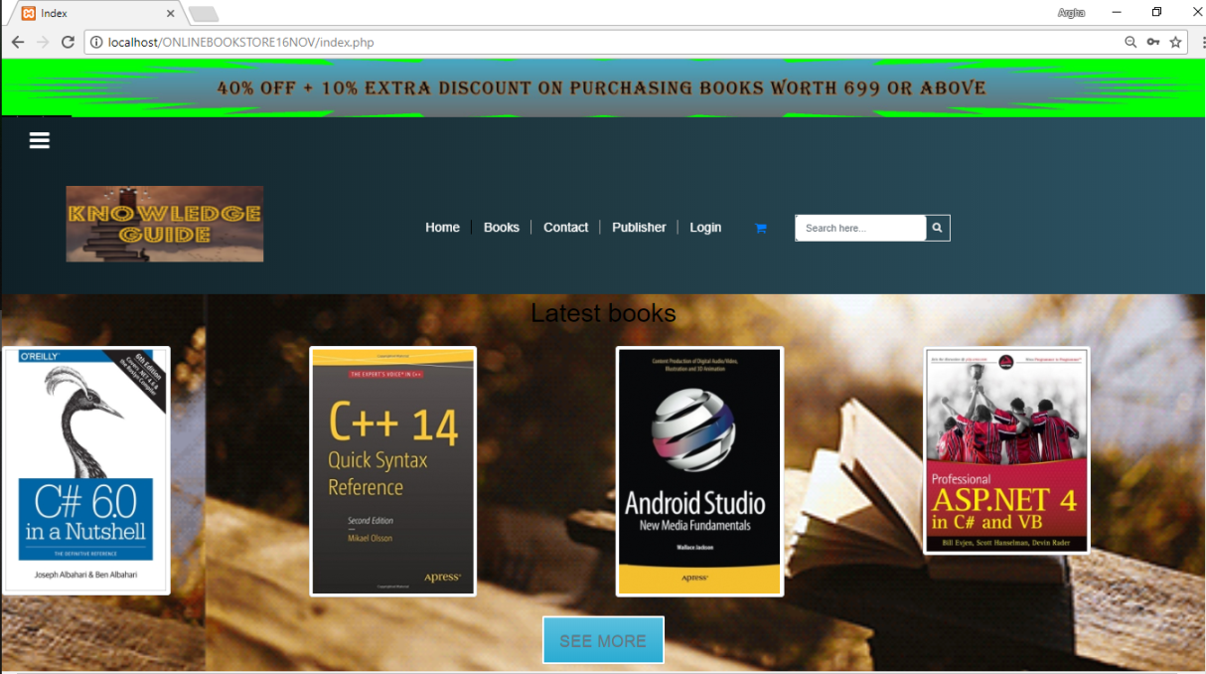

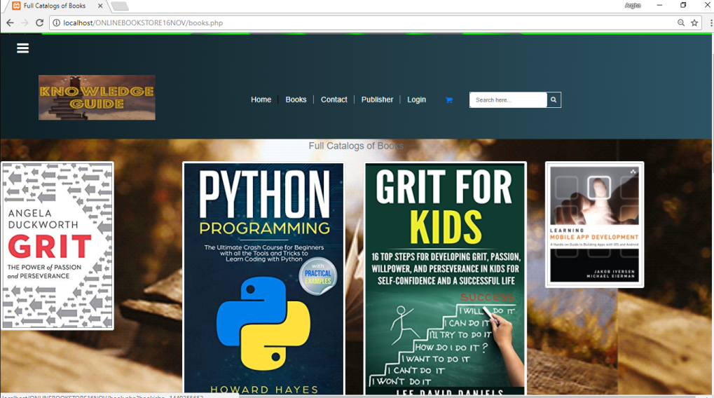

**BOOKS PAGE**

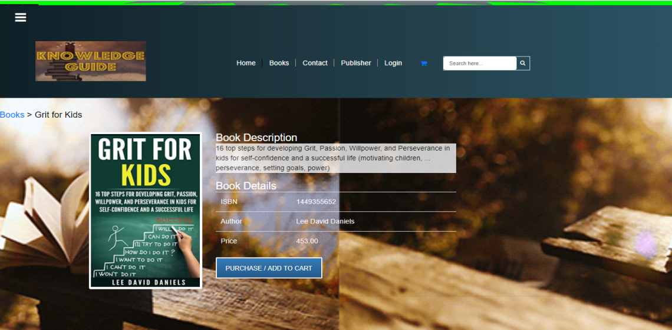

**BOOKS DETAIL PAGE**



**CART PAGE**

**PAYMENT PAGE**

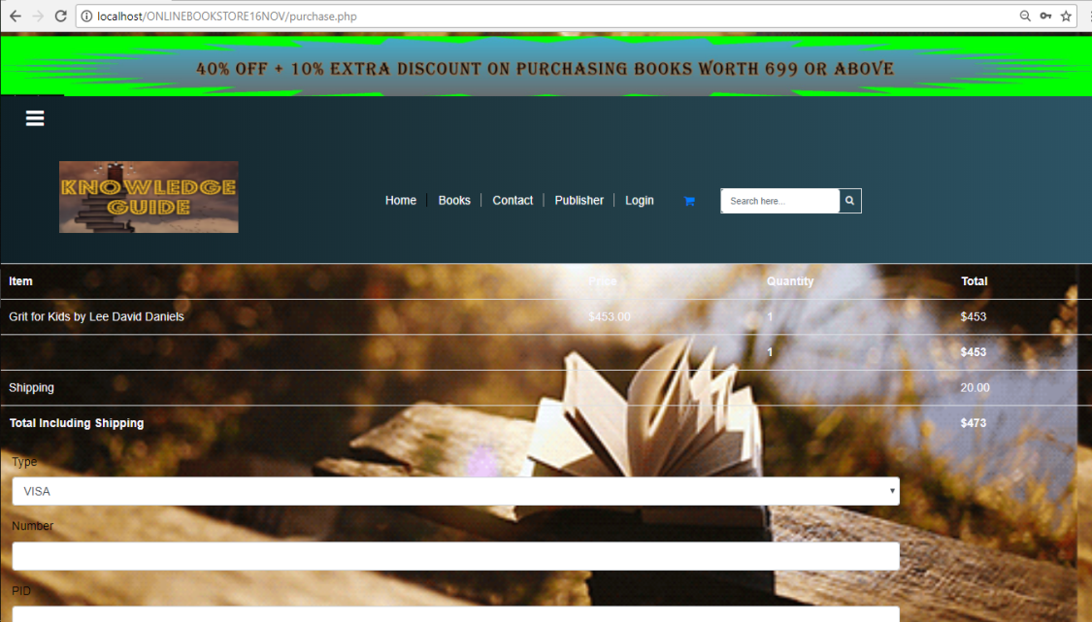

**SUCESSFUL PAGE**

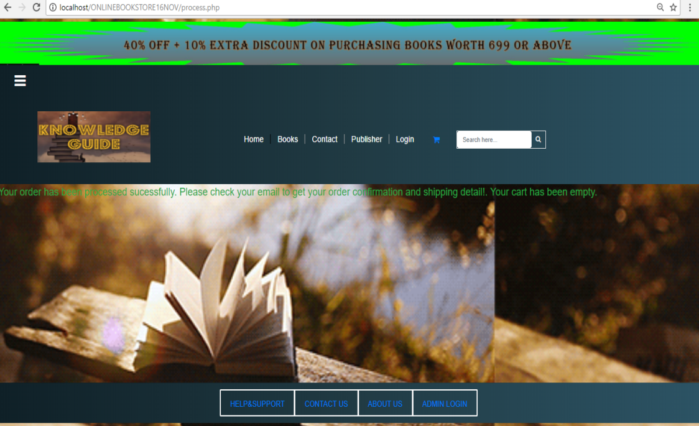

**CONNECT WITH CUSTOMER PAGE**

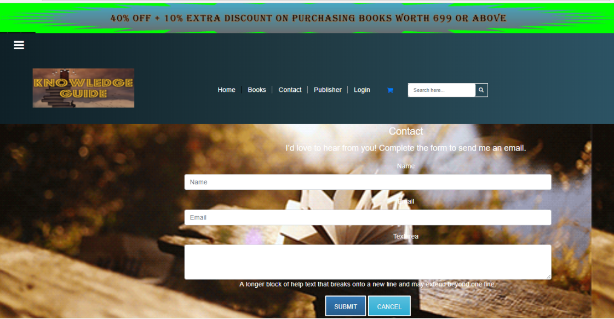

* **DATABASE DESIGN:**

**The database design or table design is the organization of data according to the database model. The database design involves classifying the data and identifying the interrelationships between them.**

**The database name is bookstore.**

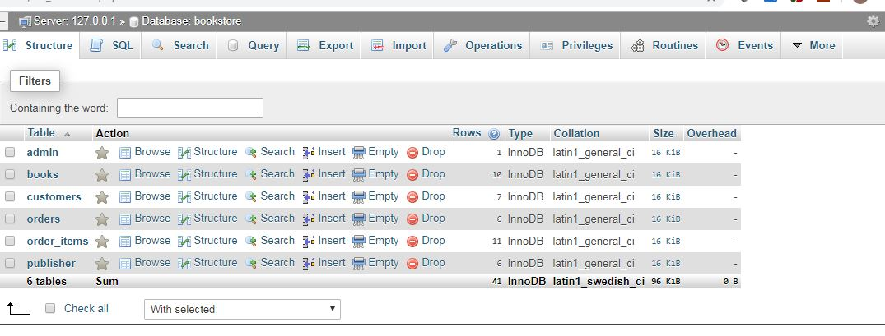

**The following tables are used:**

1. **Admin - to store the admin information.**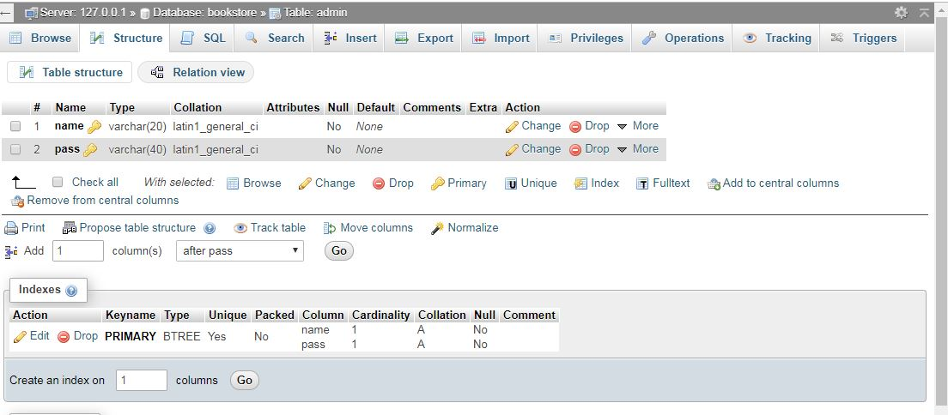
2. **Books- to store the details of the available books**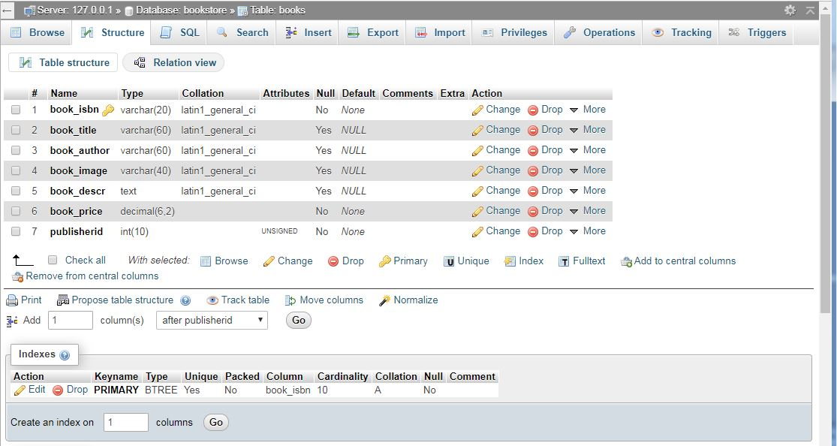
3. **Customer- to store the customer information.**

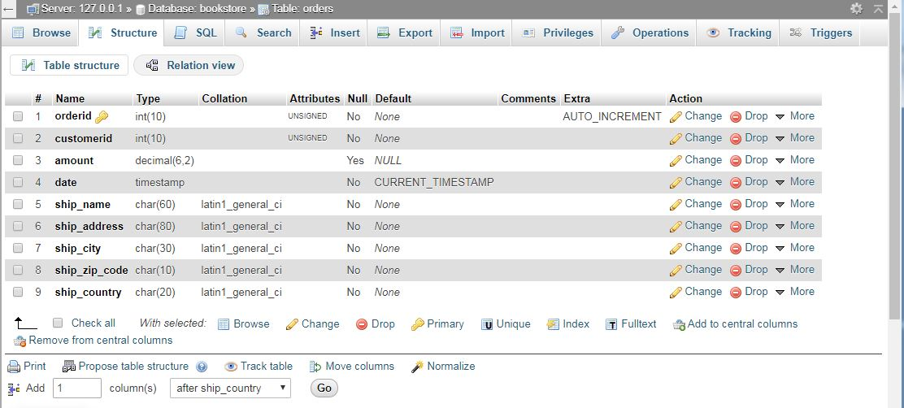

1. **Orders-to store the order details**

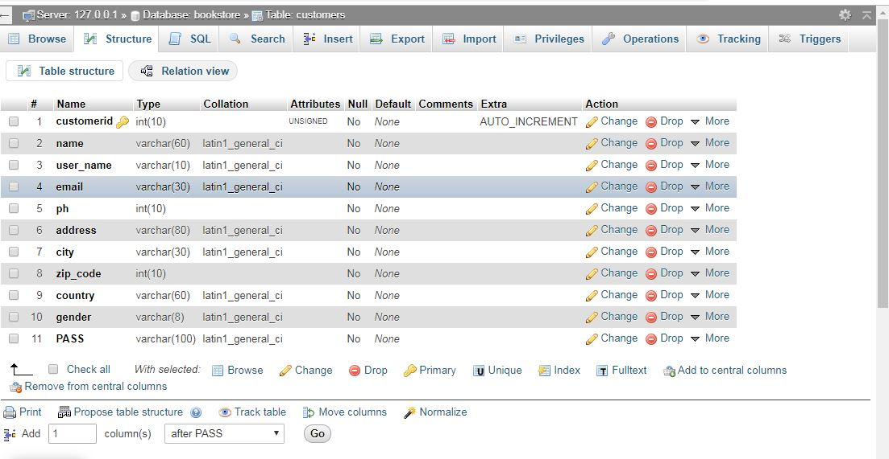

1. **Order_items- to store the details of the items ordered.**

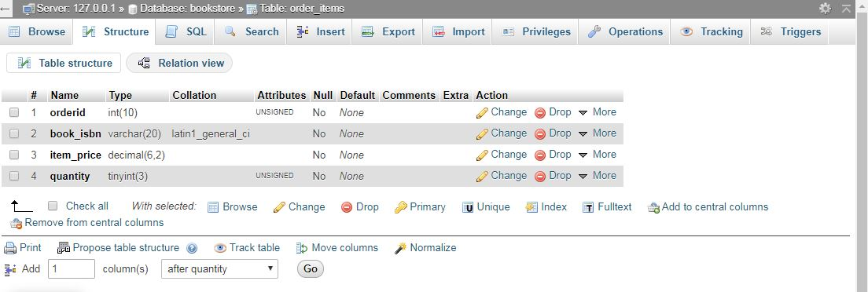

1. **Publisher –to store the details of the available publishers**

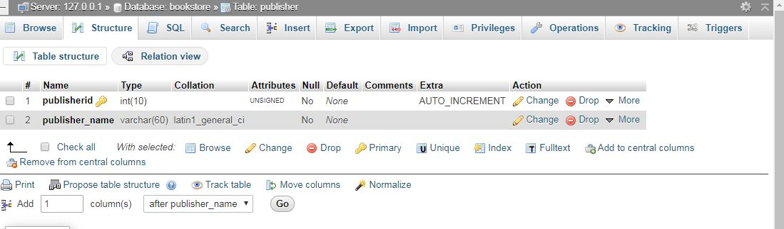

* **SOURCE CODES**

**The following source codes are implementated:**

**1.Registration page:**

* **registration.php**

**<?php**

**session_start();**

**require_once "./functions/database_functions.php";**

**$conn = db_connect();**

**if($_POST['signup']|| $_POST['signin'] ){**

**$count=0; //up**

**$counts=0; //in**

**if($_POST['signup']){**

**$count=1;**

**$counts=0;**

**}**

**else if($_POST['signin'] ) {$count=0;**

**$counts=1; }**

**}**

**?>**

**<?php**

**if($count){**

**$name =$_POST['name'];**

**$usN =strtolower( $_POST['username']);**

**$em =$_POST['email'];**

**$ph =$_POST['ph']; //NOT STRING**

**$add =$_POST['adddress'];**

**$ct =$_POST['city'];**

**$zp =$_POST['zipcode']; //NOT STRING**

**$cnt =$_POST['country'];**

**$gn =strtolower($_POST['gn']);**

**$passw =strip_tags($_POST['pass']);**

**$rpassw=strip_tags($_POST['re_pass']);**

**if($usN){**

**$userval="SELECT user_name FROM customers WHERE user_name = '$usN'";**

**$uservalResult = $conn->query($userval);**

**$check=$uservalResult->num_rows;**

**if($check !=0){**

**die("THIS USERNAME IS ALREADY IS TAKEN GO BACK");**

**}**

**}**

**if($name && $usN && $em && $ph && $passw && $rpassw)**

**{**

**if($passw==$rpassw){**

**if(strlen($passw) > 25 || strlen($rpassw)<6 )**

**die("Password must be between 6 and 25 characters");**

**//encropted password**

**$pass = md5($passw);**

**$rpass = md5($rpassw);**

**}**

**$query="INSERT INTO customers VALUES('','$name','$usN','$em',$ph,'$add','$ct',$zp,'$cnt','$gn','$pass')";**

**$conn->query($query) or die("no data enter");**

**die("YOu have been registered!! <a href='registration.html'> LOGI IN NOW </a>");**

**//(customerid,name,user_name,email,ph,address,city,zip_code,country,gender,PASS)**

**}**

**}**

**//for in**

**/// not initialize yet**

**if($counts){**

**$usn=strtolower($_POST['user_name']);**

**$passwa=strip_tags($_POST['your_pass']);**

**if($usn && $passwa){**

**$passwords=md5($passwa);**

**$in="SELECT user_name,PASS FROM customers WHERE user_name = '$usn'&& PASS='$passwords'";**

**$inResult = $conn->query($in);**

**if($inResult->num_rows >0){**

**while($singleRow=$inResult->fetch_assoc()){**

**$usernameDB=$singleRow['user_name'];**

**$passwordDB=$singleRow['PASS'];**

**}**

**} else{**

**die("your username is havent been register with our data base TRY AGAIN <a href=\"registration.html\">CLICK HERE</a>");**

**}**

**if($usn==$usernameDB && $passwords==$passwordDB){**

**echo "you are in ";**

**$_SESSION['USERNAME']=$usernameDB;**

**header('Location:index.php');**

**}**

**}else{ die("TRY AGAIN <a href=\"registration.html\">CLICK HERE</a>" );}**

**//<a href="registration.html">CLICK HERE </a> to Try**

**again"**

**}//**

**?>**

**2. Home page**

* **Index.php**

**<?php**

**session_start();**

**$count = 0;**

**// connecto database**

**$title = "Index";**

**require_once "template/header.php";**

**require_once "functions/database_functions.php";**

**$conn = db_connect();**

**$row = select4LatestBook($conn);**

**// if(!isset($_SESSION['USERNAME'])){**

**// header('Location:registration.html');**

**// }**

**?>**

**<!-- Example row of columns -->**

**<p class="lead text-center text-muted"><font size="6" color="blue,lighter100%">Latest books</font></p>**

**<div class="row">**

**<?php foreach($row as $book) { ?>**

**<div class="col-md-3">**

**<a href="book.php?bookisbn=<?php echo $book['book_isbn']; ?>">**

**<img class="img-responsive img-thumbnail" src="./bootstrap/img/<?php echo $book['book_image']; ?>">**

**</a>**

**</div>**

**<?php } ?>**

**</div><br>**

**<center><a href="#" class="btn btn-info"><font color="blue" class="lead text-center text-muted"> See more </font></a></center>**

**<hr size="10" color="dark_blue">**

**<p class="lead text-center text-muted"><font size="6" color="blue,lighter100%">Best Sellers</font></p>**

**<div class="row">**

**<?php foreach($row as $book) { ?>**

**<div class="col-md-3">**

**<a href="book.php?bookisbn=<?php echo $book['book_isbn']; ?>">**

**<marquee><img class="img-responsive img-thumbnail" src="./bootstrap/img/<?php echo $book['book_image']; ?>"></marquee>**

**</a>**

**</div**

**<?php } ?>**

**</div><br>**

**<center><a href="#" class="btn btn-info"><font color="blue" class="lead text-center text-muted"> See more </font></a></center>**

**<hr size="10" color="dark_blue">**

**<?php**

**if(isset($conn)) {mysqli_close($conn);}**

**require_once "./template/footer.php";**

**?>**

**3.Validation**

* **main.js**

**function fire(){**

**var frame = document.querySelector(".sign-in");**

**if(frame.style.visibility =='visible'){**

**frame.style.visibility = 'hidden';**

**}**

**else{frame.style.visibility = 'visible' }**

**}**

**function validate(){**

**var result = true;**

**var i=document.getElementsByTagName("input");**

**if (i[0].value.length==0){**

**alert("PLEASE ENTER YOUR NAME");**

**i[0].style.borderBottom= "2px solid Red";**

**i[0].focus();**

**return result=false;**

**}**

**// FOR USER NAME**

**if (i[1].value.length==0){**

**alert("PLEASE ENTER USERNAME");**

**i[1].focus();**

**i[1].style.borderBottom= "2px solid Red";**

**return result=false;**

**}**

**// EMAIL**

**if (i[2].value.length==0){**

**alert("PLEASE ENTER EMAIL ADDRESS");**

**i[2].focus();**

**i[2].style.borderBottom= "2px solid Red";**

**return result=false;**

**}**

**if (i[2].value.length > 0){**

**let atindex = i[2].value.indexOf("@")**

**let dotindex =i[2].value.lastIndexOf('.')**

**if (atindex< 1 || dotindex > i[2].value.length-2 || (dotindex-atindex) <3 ){**

**alert(` THIS ${i[2].value} IS NOT VALID EMAIL ADDRESS` );**

**i[2].focus();**

**i[2].style.borderBottom= "2px solid Red";**

**return result=false;**

**}**

**}**

**//PHONE**

**if (i[3].value.length==0){**

**alert("PLEASE ENTER PHONE NUMBER");**

**i[3].focus();**

**i[3].style.borderBottom= "2px solid Red";**

**return result=false;**

**}**

**if (i[3].value.length > 10 || i[3].value.length < 10 ){**

**alert(`PLEASE ENTER 10 DIGIT PHONE NUMBER,YOU HAVE ENTER ${i[3].value.length} DIGIT `);**

**i[3].focus();**

**i[3].style.borderBottom= "2px solid Red";**

**return result=false;**

**}**

**//ADDRESS**

**if (i[4].value.length==0){**

**alert("PLEASE ENTER ADDRESS");**

**i[4].focus();**

**i[4].style.borderBottom= "2px solid Red";**

**return result=false;**

**}**

**//CITY**

**if (i[5].value.length==0){**

**alert("PLEASE ENTER CITY");**

**i[5].focus();**

**i[5].style.borderBottom= "2px solid Red";**

**return result=false;**

**}**

**//ZIP CODE**

**if (i[6].value.length==0){**

**alert("PLEASE ENTER ZIP CODE");**

**i[6].focus();**

**return result=false;**

**}**

**//COUNTRY**

**if (i[7].value.length==0){**

**alert("PLEASE ENTER COUNTRY");**

**i[7].focus();**

**i[7].style.borderBottom= "2px solid Red";**

**return result=false;**

**}**

**// GENDER**

**if (i[8].checked == false && i[9].checked == false ){**

**alert("PLEASE CHOOSE YOUR GENDER");**

**return result=false;**

**}**

**//PASSWORD**

**if (i[10].value.length==0){**

**alert("PLEASE ENTER PASSWORD");**

**i[10].focus();**

**i[10].style.borderBottom= "2px solid Red";**

**return result=false;**

**}**

**//RE PASSWORD**

**if (i[11].value.length==0){**

**alert("PLEASE ENTER REPEAT PASSWORD");**

**i[11].focus();**

**i[11].style.borderBottom= "2px solid Red";**

**return result=false;**

**}**

**// pass checking**

**if (i[10].value != i[11].value) {**

**window.alert("\n BOTH PASSWORD MUST BE SAME! ");**

**i[11].style.borderBottom= "2px solid Red";**

**i[10].style.borderBottom= "2px solid Red";**

**return result=false;**

**}**

**return result;**

**}**

**function logVal(){**

**var result = true;**

**var k=document.getElementById("your_name");**

**var m=document.getElementById("your_pass");**

**if(k.value== 0){**

**alert("PLEASE ENTER USERNAME");**

**k.focus();**

**k.style.borderBottom= "2px solid Red";**

**return result=false;**

**}**

**if(m.value== 0){**

**alert("PLEASE ENTER PASSWORD");**

**m.focus();**

**m.style.borderBottom= "2px solid Red";**

**return result=false;**

**}**

**}**

**4. Logout**

* **logout.php**

**<?php**

**session_start();**

**session_destroy();**

**header('Location:registration.html');**

**?>**

**6 Coding standards and assumptions**

* **Simple and easily understandable codes are used which are easy to debug and maintain.**
* **Proper indentation of codes for better understanding.**
* **Meaningful variables are used.**
* **Variables are named in camelCase.**
* **The codes are well commented to increase understandability.**



**7. Testing**

**Testing was done to determine the defects in our project.**

**Our project went through two levels of testing:**

1. **UNIT TESTING**
2. **INTEGRATION TESTING**

* **UNIT TESTING:The purpose of unit testing is to validate each unit of the software performs as designed. It is the first level of software testing where the individual modules are tested. This supports the fixing of defects at a earlier stage of development which is easier and less costly.**
* **INTEGRATION TESTING: Integration testing is performed after integrating the individual units. Here the individual units are combined and tested as a group. The main purpose of integrationtesting is to expose the faults or defects when the integrated units interact.**



**8. future scope of the project**

**There are certain limitations in the current system to which solutions can be provided in the future development:**

1. **Including the digital books whose pdf can be bought from the website.**
2. **The website is not accessible to everyone. It can be deployed on a web server so that everyone can access it.**
3. **Including more advanced and better facilities for better customer interaction.**
4. **A feedback page will be provided in which users can post their reviews.**



**9. Conclusion**

**This website provides a computerized version of a bookstore which enables the customers to buy books online which reduces much of the travel time and cost. The customers can view a variety of books of all categories to choose from. The customers can search for books, later add it to the shopping cart and finally purchase it. The purchased book reaches the doorstep of the customer, thus making the process of buying books much more hassle-free and easier.**



**10. Bibliography**

**10.1 WEB REFERENCES:**

* [**https://www.w3schools.com/js/default.asp**](https://www.w3schools.com/js/default.asp)
* [**https://www.w3schools.com/php/php_forms.asp**](https://www.w3schools.com/php/php_forms.asp)
* [**https://www.w3schools.com/bootstrap4/default.asp**](https://www.w3schools.com/bootstrap4/default.asp)
* [**https://www.w3schools.com/css/css_background.asp**](https://www.w3schools.com/css/css_background.asp)
* [**https://www.w3schools.com/sql/default.asp**](https://www.w3schools.com/sql/default.asp)
* **https://www.google.com**

**10.2 BOOK REFERENCES:**

# PHP and MySQL Web Development by[Luke Welling](https://www.amazon.in/Luke-Welling/e/B001IGHRRY/ref=dp_byline_cont_book_1)  and [Laura Thomson](https://www.amazon.in/Laura-Thomson/e/B001IGJV0A/ref=dp_byline_cont_book_2) .

# HTML and CSS: Design and Build Websites

**by**[**Jon Duckett**](https://www.amazon.in/Jon-Duckett/e/B001IR3Q7I/ref=dp_byline_cont_book_1)**.**